# Experiment-2.2

## Student Name: Nabha Varshney UID: 20BCS4995

**Branch: CSE Section/Group: 20BCS-DM-704 (A)**

## Semester: 6th Date of Performance: thApr 2023 Subject Name: Data Mining Subject Code: 20CSP- 351

**Aim** – To perform the classification using Bayesian classification algorithm using R.

## Objective-

* Represent the reading of file using R studio
* Displaying the pattern on e1071, caret and caTools Tool.
* Demonstration of Non-linear classification algorithm.

**Script and Output-**

# Structure

str(iris)

#Performing Naive Bayes on Dataset

#Using Naive Bayes algorithm on the dataset which includes 11 persons and 6 variables or attributes

# Installing Packages

install.packages("e1071")

install.packages("caTools")

install.packages("caret")

# Loading package

library(e1071)

library(caTools)

library(caret)

iris_data = iris

str(iris_data)

summary(iris_data)

# Splitting data into train and test data

spl = sample.split(iris_data, SplitRatio = 0.7)

dataTrain = subset(iris_data, spl==TRUE)

dataTest = subset(iris_data, spl==FALSE)

dataTrain

dataTest

# Feature Scaling

train_scale <- scale(dataTrain[, 1:4])

test_scale <- scale(dataTest[, 1:4])

# Fitting Naive Bayes Model to training dataset

#set.seed(120) # Setting Seed

classifier_cl <- naiveBayes(Species ~ ., data = dataTrain)

classifier_cl

# Predicting on test data'

y_pred <- predict(classifier_cl, newdata = dataTest)

# Confusion Matrix

cm <- table(dataTest$Species, y_pred)

cm

# Model Evaluation

confusionMatrix(cm)

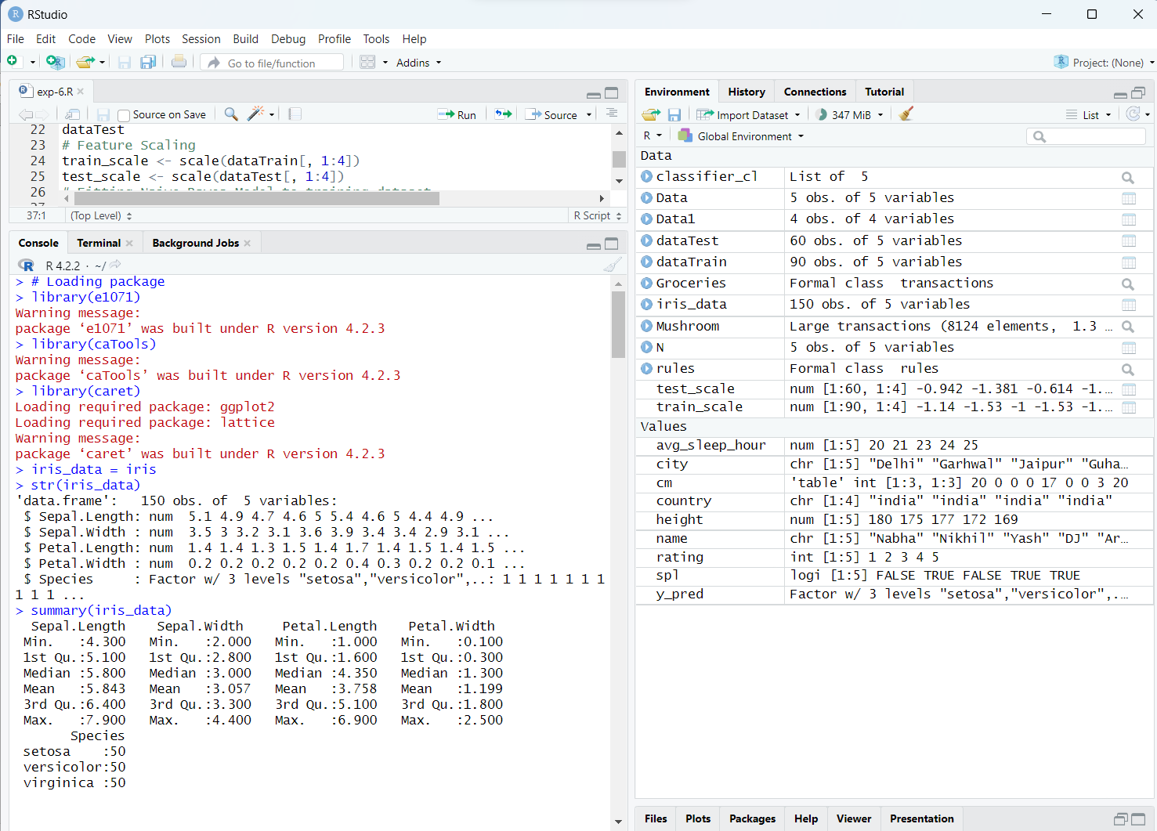**Output-**

